ASSIGNMENT NUMBER 6

STATEMENT: Create a class template to represent a generic vector. Include following member functions:
i. To create the vector.
ii. To modify the value of a given element
iii. To multiply by a scalar value
iv. To display the vector in the form (10,20,30,…)

AIM:To create a class template to represent a generic vector.

DESCRIPTION: Generics is the idea to allow type (Integer, String, … etc and user-defined types) to be a parameter to methods, classes and interfaces. For example, classes like an array, map, etc, which can be used using generics very efficiently.
OOP CONCEPT USED:

1. Class Vector : A vector is a sequence container class that implements dynamic array, means size
automatically changes when appending elements. A vector stores the elements in
contiguous memory locations and allocates the memory as needed at run time.
SOURCE CODE:
#include<iostream>
#include<vector>
using namespace std;
vector<int> v;
int v_size,v_elements,v_position,v_scalar;
vector <int>::iterator itr=v.begin();
void display()
{
for(int i=0;i<v.size();i++)
cout<<v[i]<<" ";
cout<<endl;
}
void accept()
{
cout<<"ENTER THE SIZE OF VECTOR : ";
cin>>v_size;
cout<<"\nENTER "<<v_size<<" VALUES ";
for(int i=0;i<v_size;i++)
{
cin>>v_elements;
v.push_back(v_elements);
}
display();
}
void scalar()
{
cout<<"\n ENTER THE SCALAR VALUE TO MULTIPLY: ";
cin>>v_scalar;
for(int i=0;i<v.size();i++)
v[i]=v[i]*v_scalar;
display();
}
void modify()
{
cout<<"ENTER THE POSITION TO MODIFY: ";
cin>>v_position;
itr=v.begin()+v_position;
cout<<"\nENTER THE NEW VALUE: ";
cin>>v_elements;
v.at(v_position)=v_elements;
display();
}
void insert_pos()
{
cout<<"\nENTER THE POSITION: ";
cin>>v_position;
cout<<"\nENTER THE VALUE: ";
cin>>v_elements;
itr=v.begin()+v_position;
v.insert(itr,v_elements);
display();
}
int main()
{
int ch;
accept();
do{
cout<<"1.DISPLAY \n2.MODIFY\n3.MULTIPLY\n4.INSERT AT POSITION \n5.EXIT";
cout<<"\nENTER CHOICE: ";
cin>>ch;
switch(ch)
{
case 1:display();
break;
case 2:modify();
break;
case 3:scalar();
break;
case 4:insert_pos();
break;
case 5:return 0;
default:cout<<"\nWRONG CHOICE";

}
}while(ch<=5);
return 0;
}

OUTPUT:
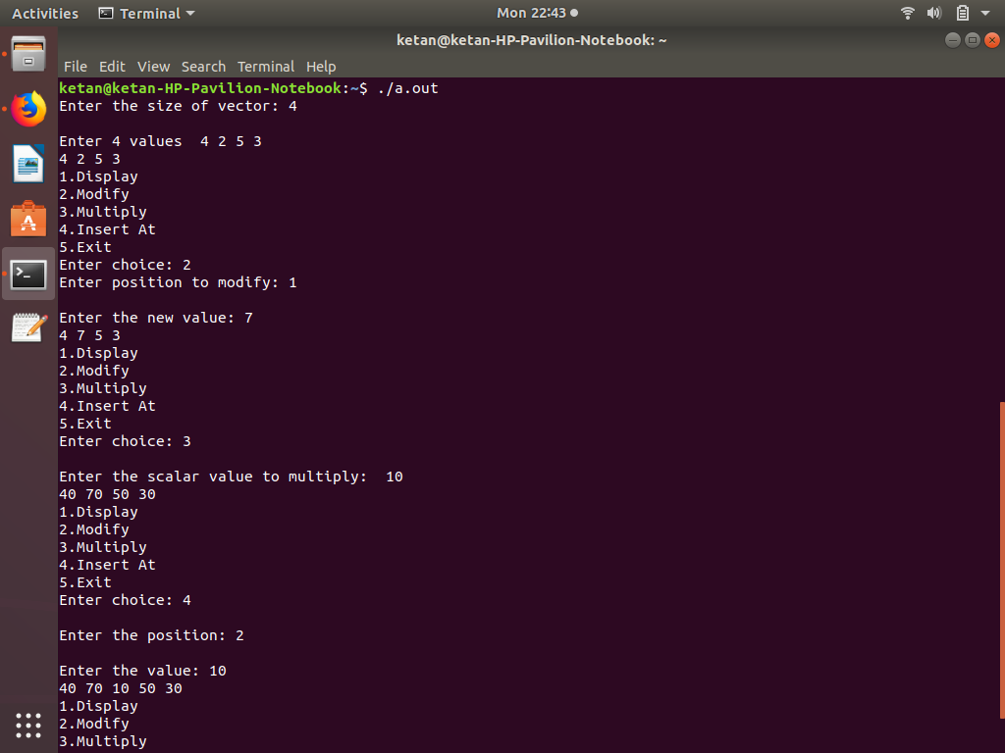

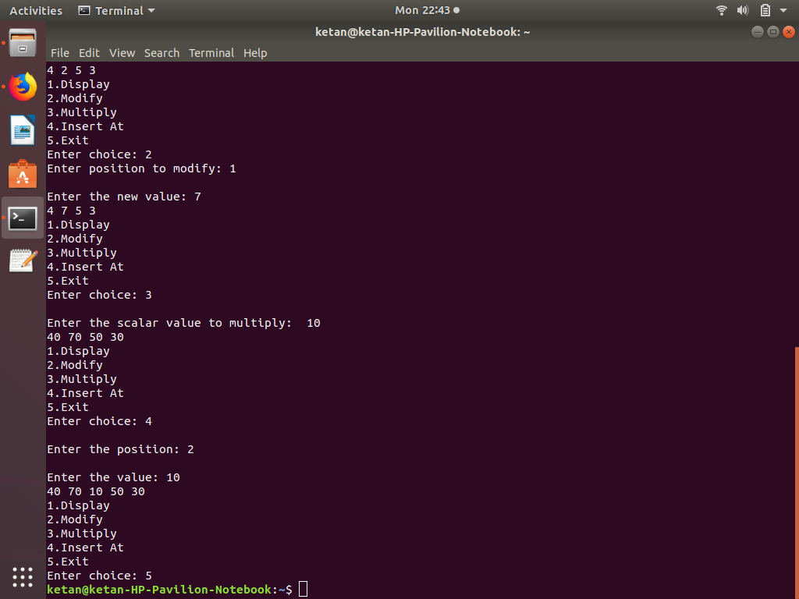
CONCLUSION: In this assignment, we learned the template class and generic vector.

